Navigate the canvas
Getting around your prezi canvas couldn’t be easier.
Zooming around: This is a key feature of Prezi, so naturally we made it simple. You can zoom in and out by using your mouse’s scroll wheel or by clicking the + and - symbols on the right hand side of your screen.
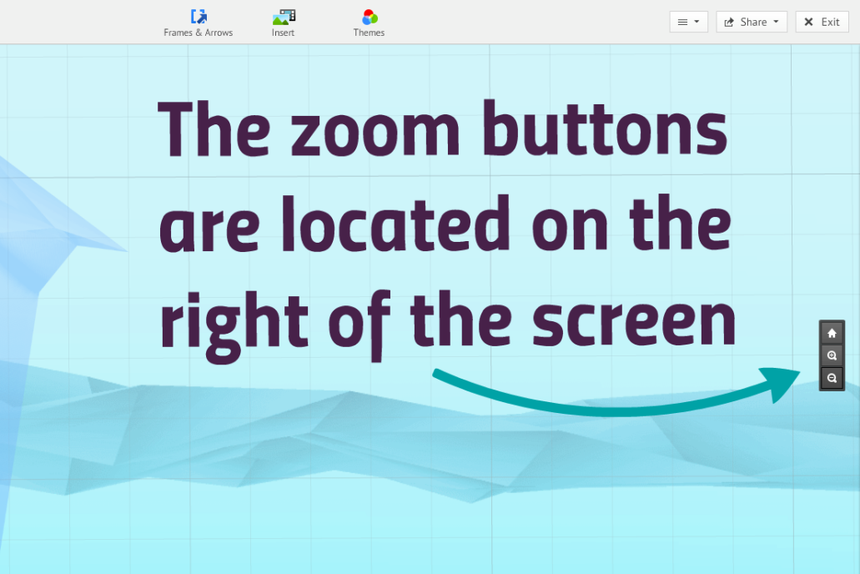
Panning: To move your prezi canvas left, right, up, or down, hold down the left button of your mouse and then move in the direction you want to go.

Get to know the Transformation Tool
In Prezi, the Transformation Tool is your best friend. Once you add anything to your canvas, click on it once to bring up the Transformation Tool. Now you can move, size, and rotate your content any way you like. If you add a frame to your prezi, you can click on it once to bring up the Transformation Tool and move, scale, or rotate everything inside.
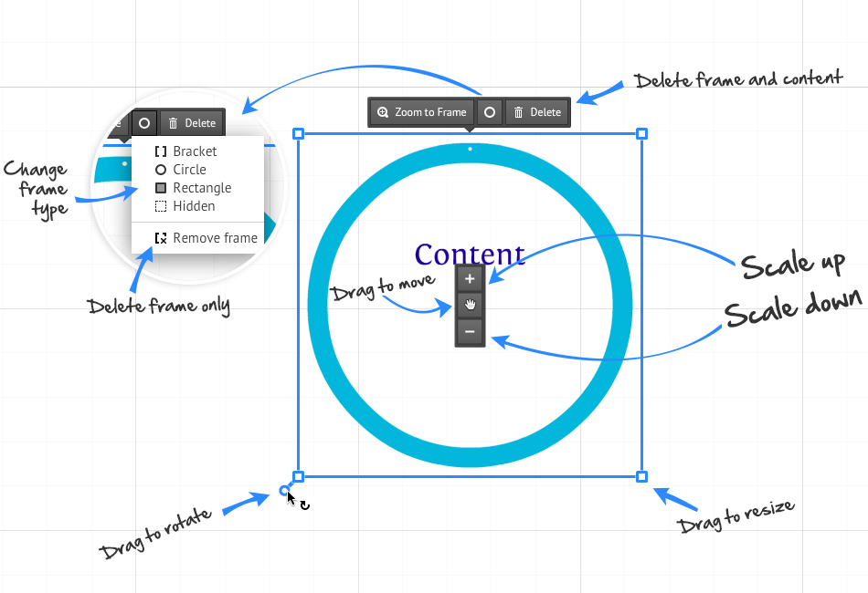

Start from a template
When you create a prezi, you can choose from a number of reusable templates or a blank canvas. When you decide to use a template, you can edit everything you see on the canvas just as if you were creating your own prezi, including copying and pasting pre-made content from other prezis or applications.
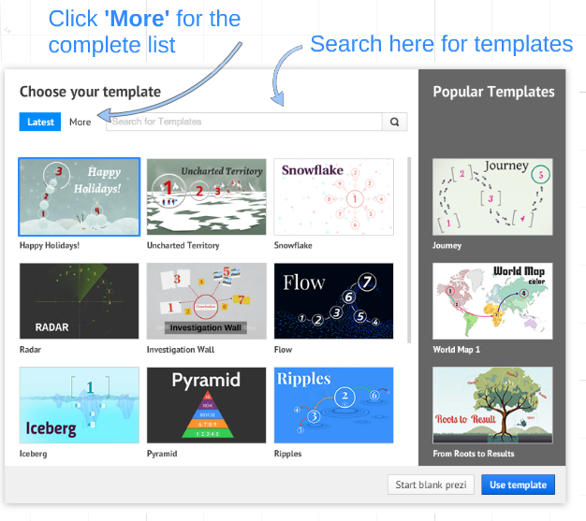

Customize colors and fonts: Theme Wizard
Use the Theme Wizard to customize the colors of your prezi and to set your font choices from Prezi's font library.
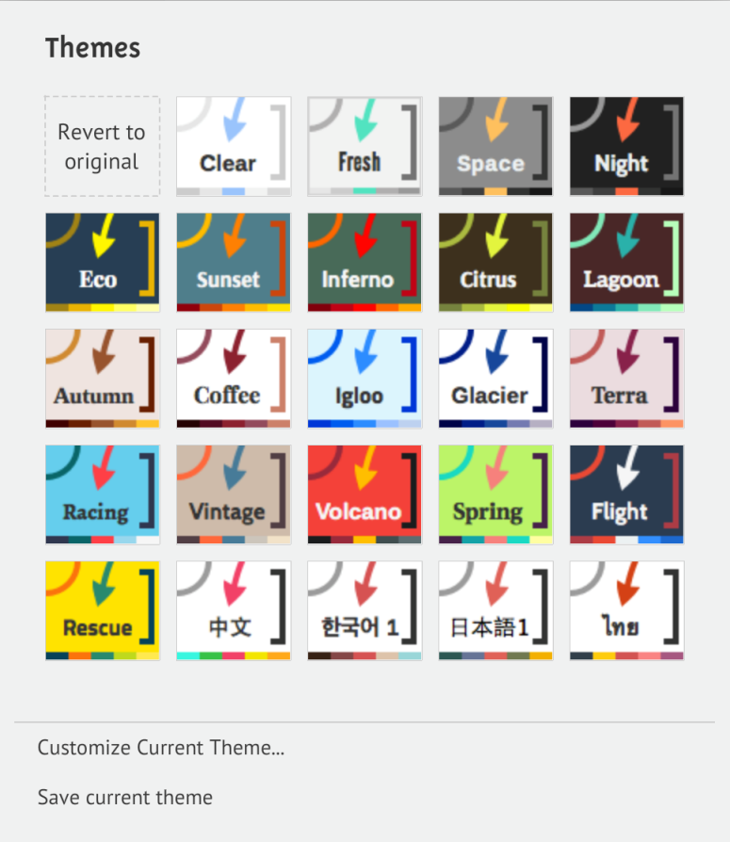
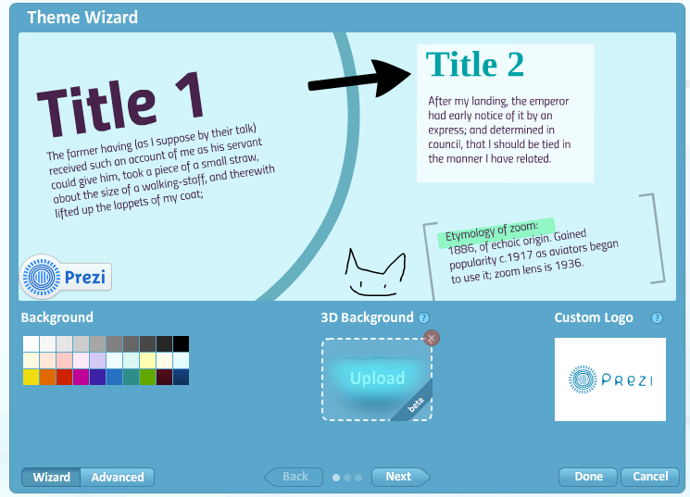
You can also create branded Prezi themes by adding your exact company colors to the wizard. Paying users (Pro, EduPro, Enjoy, and EduEnjoy license holders) can even add their own logo to a customized theme.

Anchor yourself on the canvas: The Home Button
To take a step back and get an overview of everything you've added so far (both in Edit and Present mode), you can use the Home button on the right hand side of your screen (you can find it just above the zoom + and - buttons). Clicking the Home button before you start making a prezi will also ensure that you're starting from the right place.
Back to top

Frame your content
Frames are a signature part of Prezi and a great way to manage your content. Frames work like slides and can be used to group your ideas. Use frames to create a placeholder in your prezi and then add content to them. Frames come in a variety of shapes and sizes, and you can change the color of them as well as their size and position. The other great thing about frames is that once you place one on your prezi canvas, you can move, size, and rotate it, and all the content within your frame will move, size, and rotate too.
Create frames:
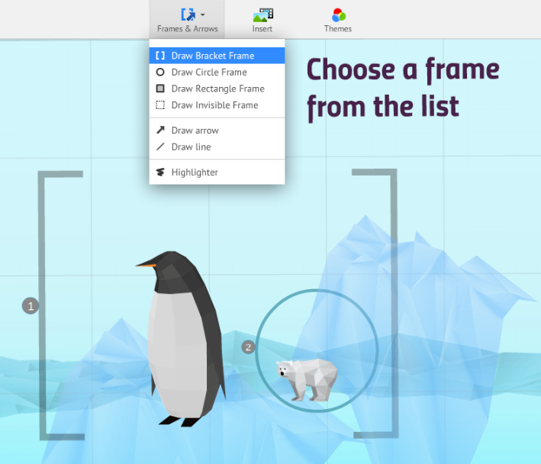
Choose 'Frames & Arrows' from the top menu.
Then choose whether you want a circle, rectangle, bracket, or invisible frame.
Use frames to add animation and take your audience through your prezi.

Insert diagrams
Prezi has created layout drawings, diagrams, and charts that can help you better communicate your ideas to your audience.
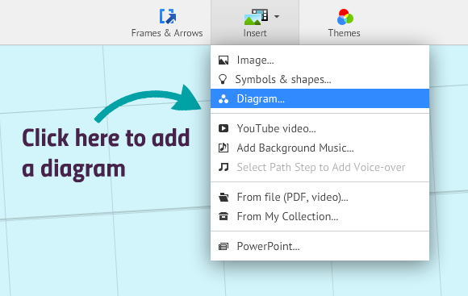
Quickly add content to your diagrams, and duplicate them (using the right-click menu or keyboard shortcuts) to start filling your prezi with inspiring content.
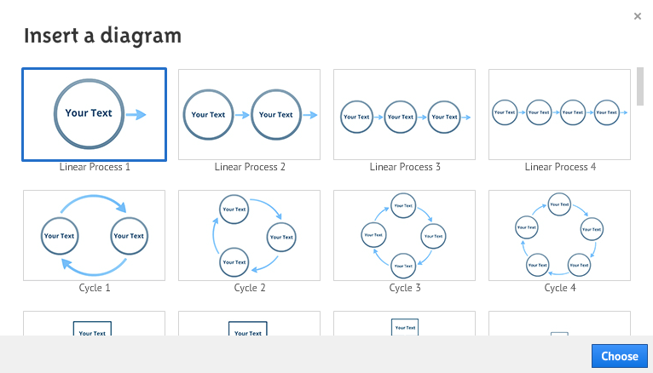

Add symbols and shapes
Click 'Insert' and then select the ‘Symbols and shapes’ icon at the top of the screen to add shapes, lines, arrows, and more to your prezi.
Insert rectangles, circles, and triangles to frame your content. Alternatively, add symbols from a huge library or purpose designed drawings to further enhance your prezi.
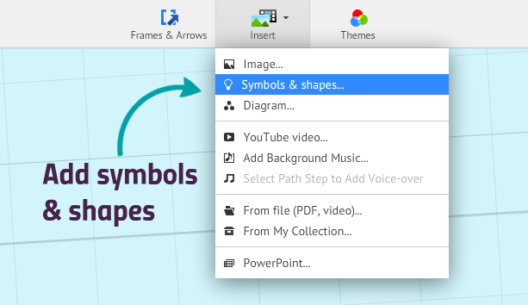

Add URLS to your prezi
To put live links into your prezi, copy and paste the desired URL into a text box. Then click away from the text box and your link will become active (you will see it automatically underline).
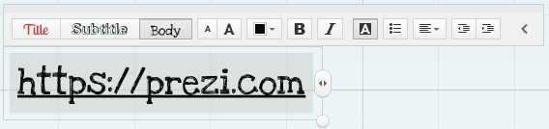

Path: navigate and rearrange with the Path sidebar
When presenting your ideas, it can sometimes help to have a clear narrative that takes your audience through your prezi. With the Left Sidebar, you can create a journey from one idea to the next. Edit your path and its points in Edit mode and take your audience along that path in Present mode.
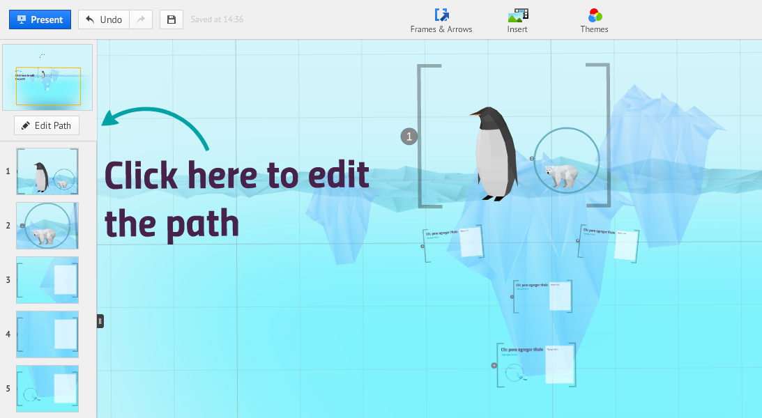
To set your path, click the 'Edit Path' on the left-hand side of screen. Then click on the objects in your prezi canvas in the order you wish them to appear.
You can also use the sidebar to rearrange and delete path points or to zoom to a specific path point.

“Borrow” from other prezis
On the Prezi Explore page you can find loads of great prezis from which you can “borrow” content, animations or even sound effects. Reusing content in this way allows you to share your ideas more effectively and is a great way to get started with Prezi. To use content from another prezi, first select a reusable prezi you like from the Explore page, then click ‘Save a copy’ to place a copy of the prezi in your own prezi library. From here, you can open the prezi and start putting your own content into it. Alternatively, cut and paste the elements you like into one of your own prezis.
Home button before you start making a prezi will also ensure that you're starting from the right place.

Frame your content
Frames are a signature part of Prezi and a great way to manage your content. Frames work like slides and can be used to group your ideas. Use frames to create a placeholder in your prezi and then add content to them. Frames come in a variety of shapes and sizes, and you can change the color of them as well as their size and position. The other great thing about frames is that once you place one on your prezi canvas, you can move, size, and rotate it, and all the content within your frame will move, size, and rotate too.
Create frames:
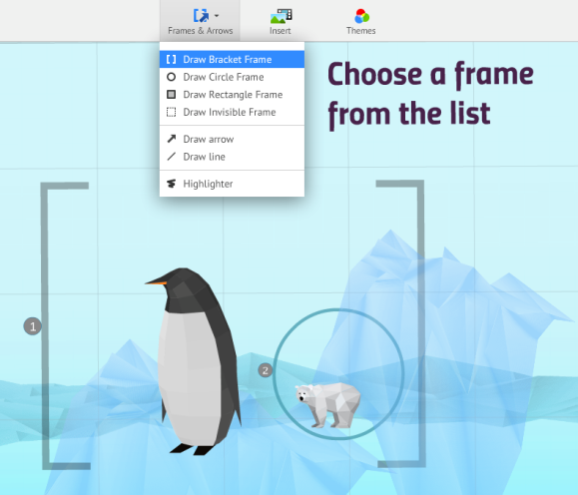
Choose 'Frames & Arrows' from the top menu.
Then choose whether you want a circle, rectangle, bracket, or invisible frame.
Use frames to add animation and take your audience through your prezi.

Insert diagrams
Prezi has created layout drawings, diagrams, and charts that can help you better communicate your ideas to your audience.
Quickly add content to your diagrams, and duplicate them (using the right-click menu or keyboard shortcuts) to start filling your prezi with inspiring content.
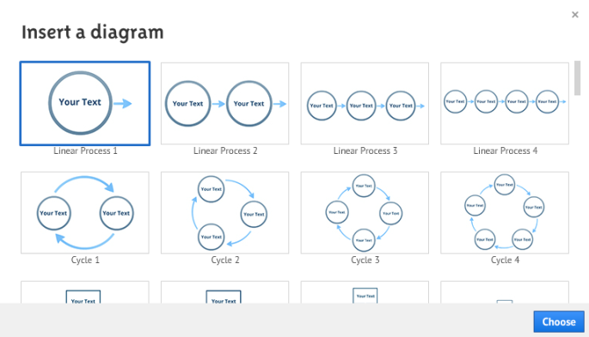

Add symbols and shapes
Click 'Insert' and then select the ‘Symbols and shapes’ icon at the top of the screen to add shapes, lines, arrows, and more to your prezi.
Insert rectangles, circles, and triangles to frame your content. Alternatively, add symbols from a huge library or purpose designed drawings to further enhance your prezi.

Add URLS to your prezi
To put live links into your prezi, copy and paste the desired URL into a text box. Then click away from the text box and your link will become active (you will see it automatically underline).

Path: navigate and rearrange with the Path sidebar
When presenting your ideas, it can sometimes help to have a clear narrative that takes your audience through your prezi. With the Left Sidebar, you can create a journey from one idea to the next. Edit your path and its points in Edit mode and take your audience along that path in Present mode.
To set your path, click the 'Edit Path' on the left-hand side of screen. Then click on the objects in your prezi canvas in the order you wish them to appear.
You can also use the sidebar to rearrange and delete path points or to zoom to a specific path point.

“Borrow” from other prezis
On the Prezi Explore page you can find loads of great prezis from which you can “borrow” content, animations or even sound effects. Reusing content in this way allows you to share your ideas more effectively and is a great way to get started with Prezi. To use content from another prezi, first select a reusable prezi you like from the Explore page, then click ‘Save a copy’ to place a copy of the prezi in your own prezi library. From here, you can open the prezi and start putting your own content into it. Alternatively, cut and paste the elements you like into one of your own prezis.

Insert Powerpoint Slides
- Choose Insert menu > Drag and drop individual slides on canvas
- You may want to group slides 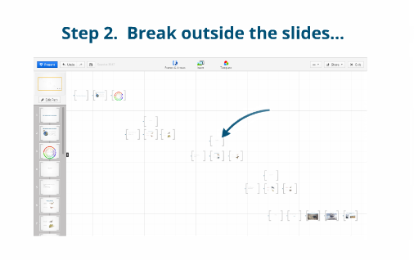
- You may want to add arrows
Transitions
- Sometimes it is effective to rotate an image or frame > big rotations dizzying effect > keep under 90 degrees and only use for dramatic effect
- Proximity The farther away objects are placed the faster the transition and sometimes this has a dizzying effect. Generally place objects close together
- Scale: Keep objects close and consider placing a few objects in the same frame

Creating frames:

Creating frames:
1. Click on 'Frames & Arrows' from the top menu.
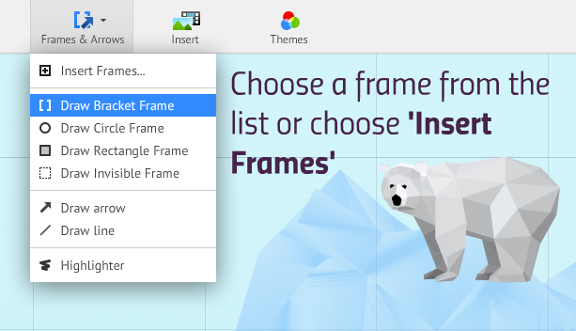
2. From here you can select the kind of frame you would like to add from the list, or simply click 'Insert Frames...'.
3. After selecting 'Insert Frames...', a sidebar will appear allowing you to choose a frame shape and potential layout. Click the icon of your choice to insert that frame into your prezi.
4. If you prefer to draw a frame directly onto your canvas, hold down the left mouse button and drag to start drawing a frame.
- Hold down the SHIFT key while drawing to create frames with 4:3, projector-friendly aspect ratios.
Note: If you create a new frame within another frame that is already part of your path, the new frame will also be added to your path.
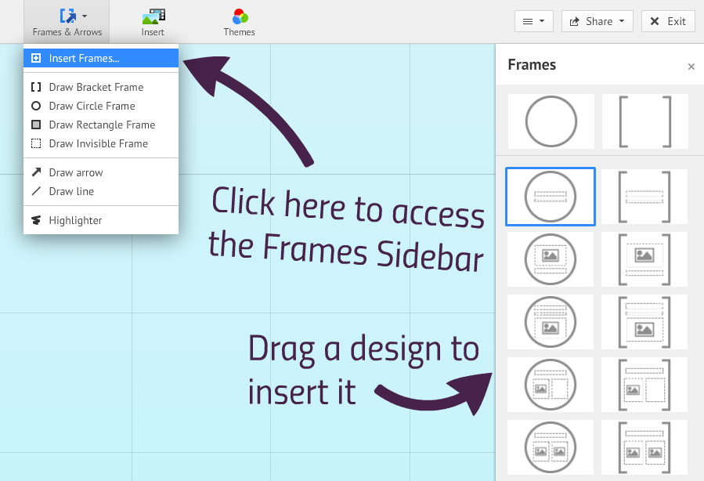

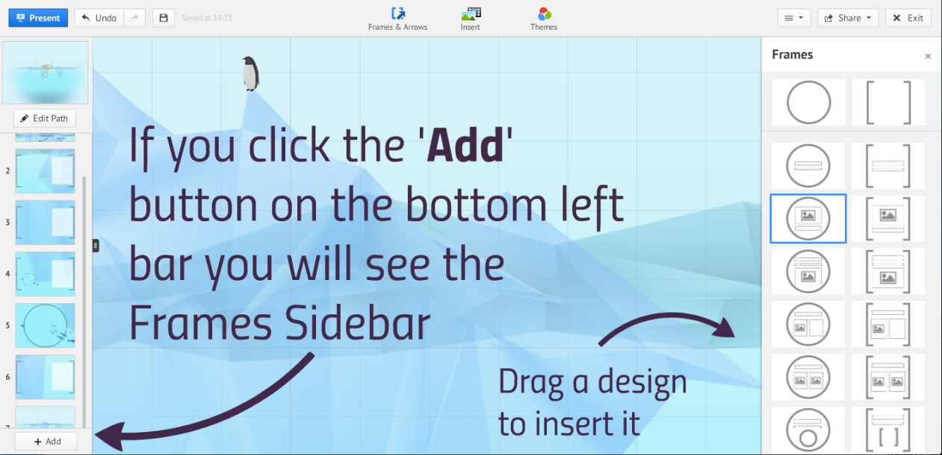

Moving, scaling, and rotating frames and their contents:
- Moving/scaling/rotating a frame will move/scale/rotate the contents of that frame.
- To remove an object from a frame, drag the object out of the frame at any time.
- Hold the ALT key while dragging or clicking on a frame to move, scale, or rotate it separately.
- Double clicking on a frame will zoom in on the frame.

Invisible frames:
- Use invisible frames to organize your content without the added visual of a normal frame. This is ideal for highlighting details on a large image or block of text. This makes invisible frames really useful if you want to present your prezi without setting a predefined path.
- Invisible frames can also be added to your prezi if you click on 'Add current view' when editing your prezi's path. This will generate an invisible frame based on the actual view that is currently filling your screen, and it will also add a step to your path.
A 3D background adds greater depth to background images and enhance the visual experience of your prezi.
- Tutorial: https://prezi.zendesk.com/entries/22375592

Embedding a prezi is done with a simple piece of HTML code. To generate this code and set your preferences for an embedded prezi:
- Go to your prezi library.
- Select the prezi you want to embed and click on the 'Embed' button underneath your prezi. Alternatively, you can click the share arrow icon that appears in the top-right corner of your prezi when you hover your mouse pointer over the prezi itself.
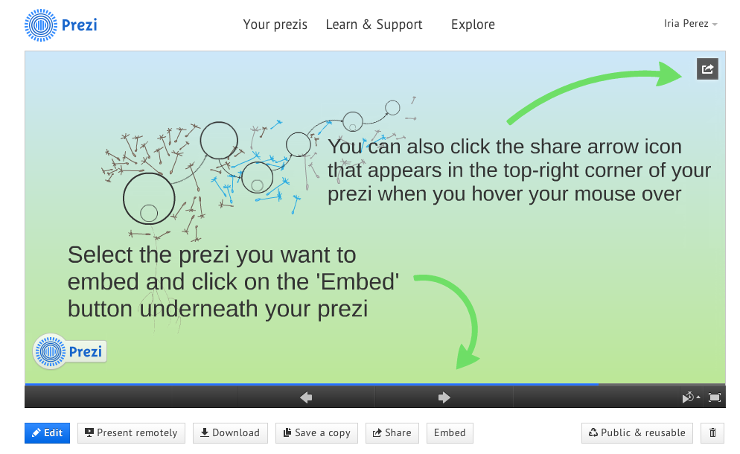
- Clicking the 'Embed' button will open a new box. From here, click 'Copy code to clipboard' to copy the embed code to your clipboard. You can alter the width or height of the prezi using the boxes marked 'Height' and 'Width'. You can also chose to allow viewers to pan & zoom freely or to constrain them to simple back and forward steps using the two check boxes.

How to create a Portable Prezi:
- Go to your Prezi library.
- Click on the prezi you want to make into a portable prezi.
- Select 'Download' from the choices along the bottom of the screen.
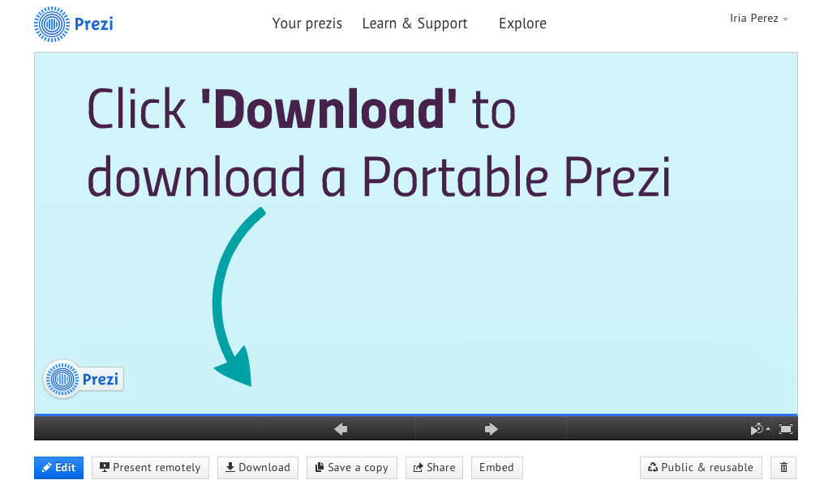
- Choose the presenting tab and then click on 'Download'.
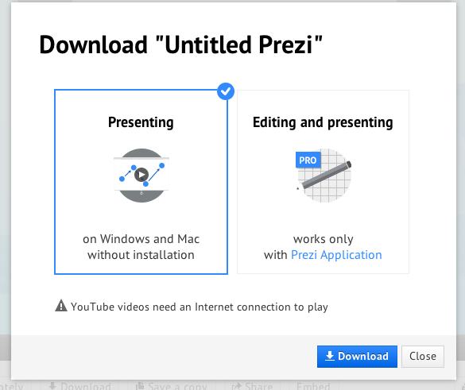
- Then, depending on the speed of your computer and Internet connection, you will have to wait a few moments.

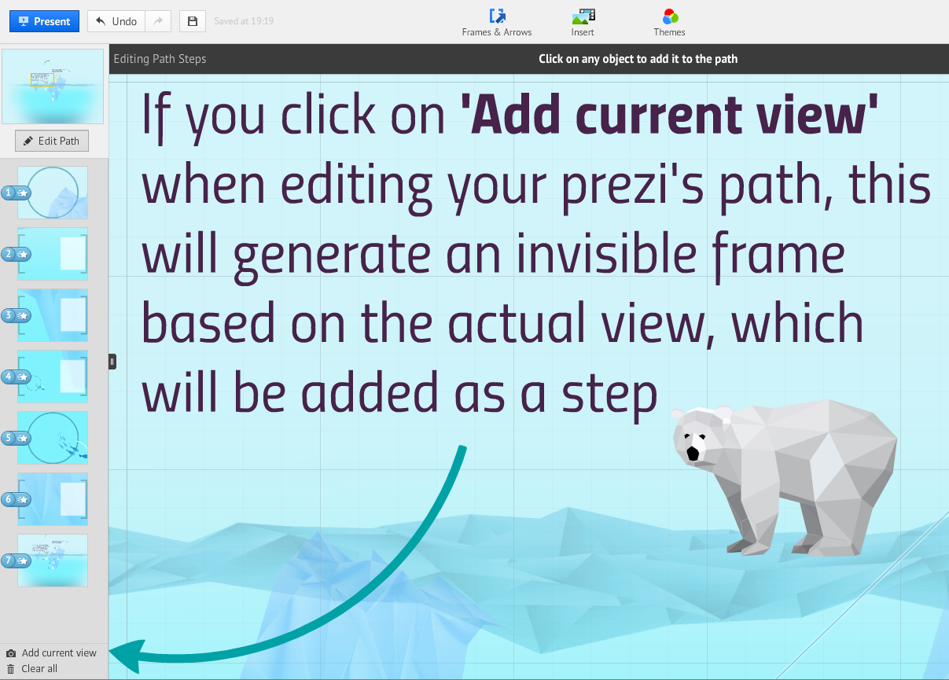

Changing the color and shape of frames
You can change the type (shape) of frame by clicking the frame and selecting the circle icon that appears above your selected frame. Clicking this will bring up a drop-down menu of options for you to choose from. See the screenshot below for an example.
To change the color of a frame, you will need to edit your theme choices from the templates tab on the top menu. You can find more detailed information on how to do this here.

Deleting frames
To delete a frame, simply select it and click on 'Delete' from the options that appear on the Transformation Tool.
Deleting a frame will delete all the content within it. To delete just the frame, click the frame delete button to the left of the delete button.
Note: to select a frame before deleting it, make sure that you are zoomed our far enough to view the whole frame.

Making Frames the same size
The easiest way to create a frame that is the same size as an existing frame is to use the ctrl+D (cmd+D) keyboard shortcut. This keyboard shortcut will duplicate any content. For more on keyboard shortcuts, click here.

