Photos and videos
Photos lets you view your:
- Camera Roll—photos and videos you took on iPad, or saved from an email, text message, webpage, or screenshot
- Shared photos and videos—Photos and videos that you’ve shared with iCloud Photo Sharing or that other have shared with you (see iCloud Photo Sharing)
- Photos and videos synced from your computer (see Sync with iTunes)
- View your photos and videos. Tap Photos.> Photos automatically organizes your photos and
videos by year, by collection, and by moment. To quickly browse the photos in a collection or year, touch and hold for a moment, then drag. To leave year, double tap window
- To see all your photos, go to Settings > Photos & Camera and turn off Summarize Photos.
- View by location. While viewing by year, tap . Photos and videos that include location information appear on a map, showing where they were taken.
- While viewing a photo or video, tap to show and hide the controls. Swipe left or right to go forward or backward.
- Zoom in or out. Double-tap, or pinch and stretch a photo. When you zoom in, you can drag to see other parts of the photo.
- Play a video. Tap . To toggle between full-screen and fit-to-screen, double-tap the display.
- Play a slideshow: While viewing a photo, tap Share button in lower left > then tap Slideshow. Select options, then tap Start Slideshow. To stop the slideshow, tap the screen. To set other slideshow options, go to Settings > Photos & Camera.
- To stream a slideshow or video to a TV, see AirPlay
Organize your photos and videos
- Create a new album. Tap Albums, tap , enter a name, then tap Save. Select photos and videos to add to the album, then tap Done.
Note: Albums created on iPad aren’t synced back to your computer.
- Add items to an existing album. While viewing thumbnails, tap Select, select items, tap Add To, then select the album.
- Manage albums. While viewing your album list, tap Edit.
- Rename an album: Select the album, then enter a new name.
My Photo Stream
- View the photos you take with iPad on your other devices, automatically. Turn on My Photo Stream in Settings > Photos & Camera. You can also turn on My Photo Stream in Settings > iCloud > Photos.
- Photos you take are automatically added to My Photo Stream when you leave the Camera app and iPad is connected to the Internet via Wi-Fi. All photos added to your Camera Roll—including screen shots and photos saved from email, for example—appear in My Photo Stream.
- Photos added to My Photo Stream on your other devices also appear in My Photo Stream on iPad. iOS devices can keep up to 1000 of your most recent photos in My Photo Stream; your computers can keep all My Photo Stream photos permanently.
Note: Photo stream photos don’t count against your iCloud storage.
- Manage My Photo Stream contents. In your My Photo Stream album, tap Select. Save your best shots to an album on iPad: Select the photos, then tap Add To.
- Share, print, copy, or save photos to your Camera Roll album: Select the photos, then tap .
- Delete photos: Select the photos, then tap .
Note: Although deleted photos are removed from My Photo Stream on all your devices, the original photos remain in the Camera Roll on the device where they were originally taken. Photos that you save to another album on a device or computer are also not deleted. To delete photos from My Photo Stream, you need iOS 5.1 or later on iPad and on your other iOS devices.

Share photos and videos
You can share photos and videos in email, text messages, and tweets, and on Facebook and Flickr. Videos can be shared in email and text messages, and on YouTube, Facebook, and Vimeo. You can also share photos and videos using Photo Sharing, described above.
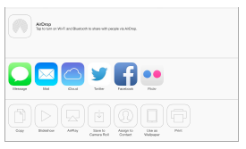
- Share or copy a photo or video. View a photo or video, then tap . If you don’t see , tap the screen to show the controls.
- You can also copy a photo or video, and then paste it into an email or text message.
- Share or copy multiple photos and videos. While viewing by moment, tap Share.
- Save or share a photo or video you receive.
  - Email: Tap to download it if necessary, then touch and hold the item to see sharing and other options.
  - Text message: Tap the item in the conversation, then tap .
  - Photos and videos that you receive in messages or save from a webpage are saved to your Camera Roll album.
Edit photos and trim videos
You can edit photos right on iPad. While viewing a photo full-screen, tap Edit, then tap one of
the tools.

- Auto-enhance improves a photo’s exposure, contrast, saturation, and other qualities.
- Photo filters lets you apply different color effects, including black & white.
- With the Remove Red-eye tool, tap each eye that needs correcting.
- Crop by dragging the corners of the grid.
- Don’t like the results? Tap the tool again to return to the original.
- Trim a video. Tap the screen to display the controls, drag either end of the frame viewer, then tap Trim.
Important: If you choose Trim Original, the trimmed frames are permanently deleted from the original video. If you choose “Save as New Clip,” a new

Import photos and videos
You can import photos and videos directly from a digital camera, from another iOS device with a camera, or from an SD memory card. For iPad (4th generation) or iPad mini, use the Lightning to SD Card Camera Reader or the Lightning to USB Camera Adapter (both sold separately). For earlier iPad models, use the iPad Camera Connection Kit (sold separately), which includes both an SD card reader and a camera connector.

Photos settings
Settings for Photos are in Settings > Photos & Camera. These include:
- My Photo Stream and Photo Sharing | Photos tab | Slideshow

Camera
Quick! Get the camera! Swipe up from the bottom edge of the screen to open Control Center,
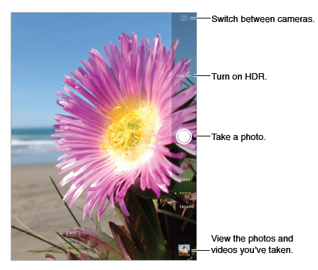
then tap .
- With iPad, you can take both still photos and videos using the front FaceTime camera or the back camera.

Take photos and videos
- Drag up or down to choose the Camera mode for still photos, square-format photos, or videos.
- Take a photo. Choose Photo, then tap the shutter button or press either volume button.
- Zoom in or out. Stretch or pinch the image on the screen. For some models, zoom is available in video mode as well as photo mode.
- Shoot some video. Choose Video, then tap the Shutter button or press either volume button to start and stop recording.
- Capture what’s displayed on your screen Simultaneously press and release the Sleep/Wake and Home buttons. The screenshot is added to your Camera Roll.
HDR
HDR (high dynamic range) helps you get great shots, even in high-contrast situations. The best parts of three quick shots, taken at different exposures (long, normal, and short), are blended together into a single photo.
- Use HDR. Tap HDR. For best results, keep both the camera and the subject still.
- Keep the normal photo in addition to the HDR version. Go to Settings > Photos and Camera.

Camera settings
Go to Settings > Photos & Camera for camera options

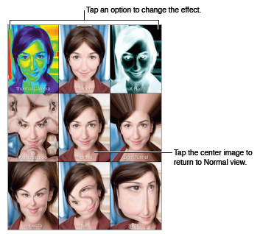
Photo Booth
Take a photo with Photo Booth and spice it up with effects.

- Select an effect. Tap , then tap the effect you want.
- Change a distortion effect: Drag your finger across the screen.
- Alter a distortion: Pinch, swipe, or rotate the image.
- To see results Tap the thumbnail of your last shot.
- To display the controls again, tap the screen.
- Switch between cameras. Tap at the bottom of the screen.

iMessage service
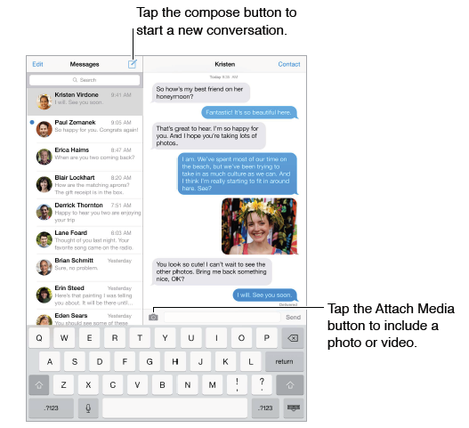
With the Messages app and the built-in iMessage service, you can send unlimited text messages over Wi-Fi using iOS 5 or later, or using OS X Mountain Lion or later. Messages can include photos, videos, and other info. You can see when people are typing, and let them know when you’ve read their messages. iMessages are displayed on all of your iOS devices logged in to the same account, so you can start a conversation on one device and continue it on another. For security, iMessages are encrypted before they’re sent.

Send and receive messages
- Start a text conversation. Tap , then enter a phone number or email address, or tap and choose a contact.
Note: Ain a conversation to try sending the message again.
- Resume a conversation. Tap the conversation in the Messages list.
- See what time a message was sent or received. Drag any bubble to the left.
- Make a FaceTime call to the person you’re texting. Tap Contact at the top of the screen, then tap .
- See earlier messages in the conversation. Tap the status bar to scroll to the top. Tap Load Earlier Messages, if necessary.
- Send messages to a group. Tap , then enter multiple recipients.

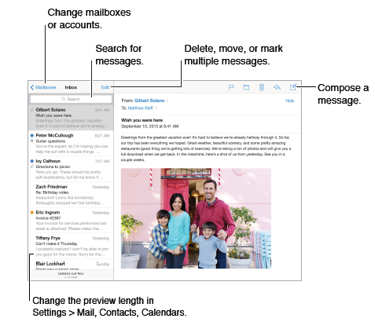
Mail
Write messages
- Insert a photo or video. Tap the insertion point, then tap Insert Photo or Video.
- Send a message from a different account. Tap the From field to choose an account.
- Finish a message later
- Save it, don’t send it. If you’re writing a message and want to finish it later, tap Cancel, then tap Save Draft.
- Finish a saved draft. Touch and hold Compose. Pick the draft from the list, then finish it up and send, or save it again as a draft.
- Show draft messages from all of your accounts. While viewing the Mailboxes list, tap Edit, tap Add Mailbox, then turn on the All Drafts mailbox.
- Delete a draft. In the Previous Drafts list, swipe left across a draft, then tap Delete.
- Search for a message. Scroll to or tap the top of the message list to reveal the search field. You can search the current mailbox, or all mailboxes at once. Searching looks at the address fields, the subject, and the message body.
- Attachments
  - Save a photo or video to your Camera Roll. Touch and hold the photo or video until a menu appears, then tap Camera Roll.
  - Use an attachment with another app. Touch and hold the attachment until a menu appears, then tap the app you want to open the attachment with.
  - Include attachments in your reply. When you reply to a message, attachments aren’t included. To include them, forward the message instead.
  - See messages with attachments. The Attachments mailbox shows messages with attachments from all accounts. To add it, view the Mailboxes list and tap Edit.
- Mail settings
  - Go to Settings > Mail, Contacts, Calendars, where you can:
  - Add mail accounts
  - Turn on Organize by Thread to group related messages together
  - Turn off confirmation for deleting a message
Music
iTunes Radio
Featured stations provide a great way to explore and enjoy new music in a variety of genres. You
can also create your own custom stations, based on your pick of artist, song, or genre.
Note: iTunes Radio may not be available in all areas.
- Get music and other audio content onto iPad:
- Purchase and download from the iTunes Store: In Music, tap Store.

FaceTime
Use FaceTime to make video or audio calls to other iOS devices or computers that support
FaceTime. The FaceTime camera lets you talk face-to-face; switch to the rear iSight camera to
share what you see around you.
- Go to Settings and make sure FaceTime is turned on
Note: FaceTime may not be available in all areas. On iPad Wi-Fi + Cellular models, you can make
FaceTime calls over a cellular data connection.

- Make a FaceTime call. Make sure FaceTime is turned on in Settings > FaceTime, then in FaceTime, tap Contacts or add contact (tap add email > keep tapping the + until you other ) sand choose a contact. Tap to make a video call, or tap to make an audio call.e
- Use your voice to start the call. Press and hold the Home button, then say “FaceTime,” followed by the name of the person to call.
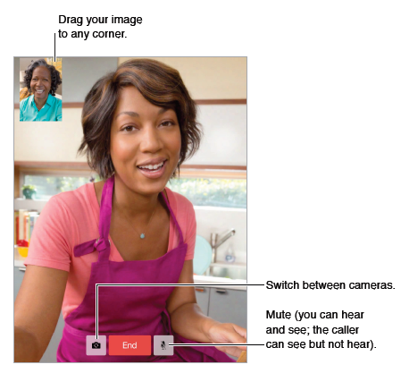
- Want to call again? Tap Recents, then choose a name or number.

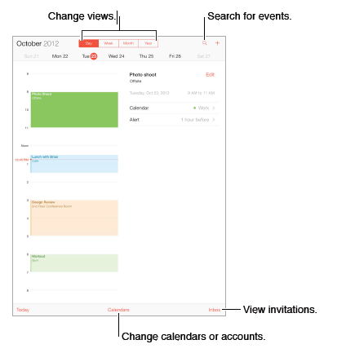
Calendar
- Search for events. Tap , then enter text in the search field.
- Change your view. Tap Day, Week, Month, or Year. Tap to view upcoming events as a list.
- Adjust an event. Touch and hold the event, then adjust the grab points, or drag it to a new time.
Calendar settings
There are several settings in Settings > Mail, Contacts, Calendars that affect Calendar and your calendar accounts. These include:
- Syncing of past events (future events are always synced)
- Alert tone played for new meeting invitations
- Default calendar for new events
Invitations
If you have an iCloud account, a Microsoft or Exchange account you can send and receive meeting invitations.
- Invite others to an event. Tap an event, tap Edit, then tap Invitees. Type names, or tap to pick people from Contacts.
- RSVP. Tap an event you’ve been invited to, or tap Inbox and tap an invitation. If you add comments (which may not be available for all calendars), your comments can be seen by the organizer but not by other attendees.
- Schedule a meeting without blocking your schedule. Tap the event, then tap Availability and tap “free.” If it’s an event you created, tap “Show As” and then tap “free.” The event stays on your calendar, but it doesn’t appear as busy to others who send you invitations.
Use multiple calendars
- Turn on iCloud, Google, Exchange, or Yahoo! calendars. Go to Settings > Mail, Contacts, Calendars, tap an account, then turn on Calendar.
- View Facebook events. Go to Settings > Facebook, then sign in to your Facebook account and turn on access to Calendar.
- See multiple calendars at once. Tap Calendars, then select the calendars you want to view.
- Move an event to another calendar. Tap the event, tap Edit, then select a calendar to move it to.
- You can subscribe to any calendar that uses the iCalendar (.ics) format. Supported calendar-based services include iCloud, Yahoo!, Google, and the Calendar application in OS X. You can read events from a subscribed calendar on iPad, but you can’t edit events or create new ones.
- Subscribe to a calendar. Go to Settings > Mail, Contacts, Calendars, then tap Add Account. Tap Other, then tap Add Subscribed Calendar. Enter the URL of the .ics file to subscribe to. You can also subscribe to an iCalendar (.ics) calendar by tapping a link to the calendar.
Share iCloud calendars
You can share an iCloud calendar with other iCloud users. When you share a calendar, others can see it, and you can let them add or change events. You can also share a read-only version that anyone can view.
- Create an iCloud calendar. Tap Calendars, tap Edit, then tap Add Calendar in the iCloud section.
- Share an iCloud calendar. Tap Calendars, tap Edit, then tap the iCloud calendar you want to share. Tap Add Person and enter a name, or tap to browse your Contacts. Those you invite receive an email invitation to join the calendar, but they need an iCloud account in order to accept.
- Change a person’s access to a shared calendar. Tap Calendars, tap Edit, tap the shared calendar, then tap the person. You can turn off their ability to edit the calendar, resend the invitation to join the calendar, or stop sharing the calendar with them.
- Turn off notifications for shared calendars. When someone modifies a shared calendar, you’re notified of the change. To turn off notifications for shared calendars, go to Settings > Mail, Contacts, Calendars > Shared Calendar Alerts.
- Share a read-only calendar with anyone. Tap Calendars, tap Edit, then tap the iCloud calendar you want to share. Turn on Public Calendar, then tap Share Link to copy or send the URL for the calendar. Anyone can use the URL to subscribe to your calendar using a compatible app, such as Calendar for iOS or OS X.

Contacts
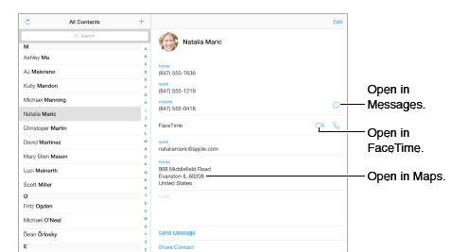
iPad lets you access and edit your contact lists from personal, business, and other accounts.
- Contacts settings
To change Contacts settings, go to Settings > Mail, Contacts, Calendars, Set your My Info card
- Set your My Info card for Safari, Siri, and other apps. Go to Settings > Mail, Contacts, Calendars, then tap My Info and select the contact card with your name and information.
- Let Siri know who’s who. While editing your My Info card, tap Add Related Name to define relationships you want Siri to know about.
- Find a contact. Use the search field at the top of the contacts list. You can also search your contacts using Spotlight Search
Videos at a glance
Open the Videos app to watch movies, TV shows, and music videos. To watch video podcasts,
install the free Podcasts app from the App Store. To watch videos you record using Camera on
iPad, open the Photos app.

Reminders 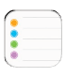lets you keep track of all the things you need to do.
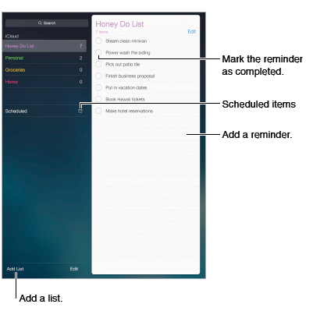
- Add a reminder. Tap a list, then tap a blank line. You can choose which of your Mail, Contacts, and Calendars accounts is used to save the reminder.
- Delete a list. While viewing a list, tap Edit, then tap Delete List.
- Delete a reminder. Swipe the reminder left, then tap Delete.
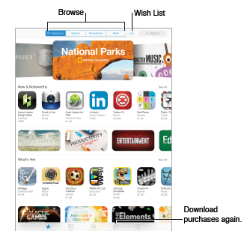
App Store at a glance
Use the App Store to browse, purchase, and download apps specifically designed for iPad, or for iPhone and iPod touch.
When you first open App Store, you’re prompted to download recommended free Apple apps,
including iBooks, iTunes U, Podcasts, Find My Friends, and Find My iPhone.

Purchase, redeem, and download
- Tap the app’s price (or tap Free), then tap Buy to purchase it. If it’s free, tap .
- Use a gift card or code. Tap Featured, scroll to the bottom, then tap Redeem.
- Delete an app. Touch and hold the app icon on the Home screen until the icon jiggles, then tap . When you finish, press the Home button. You can’t delete built-in apps. Deleting an app also deletes its data.
- You can download any app you’ve purchased on the App Store again, free of charge.

App Store settings
- To set options for App Store, go to Settings > iTunes & App Store. You can:
  - View or edit your account. Tap your Apple ID, then tap View Apple ID and log in. To change your password, tap the Apple ID field, then tap the Password field.
  - Sign in using a different Apple ID. Tap your account name, then tap Sign Out. Then enter the other Apple ID.
Turn off automatic downloads. Tap Apps in Automatic Downloads. Apps update automaticall

²³

