iPad Guide

Set up iPad
Turn on iPad and follow the Setup Assistant.
The Setup Assistant guides you through the setup process, including:
- Connecting to a Wi-Fi network
- Signing in with or creating a free Apple ID
- Entering a Passcode
- Setting up iCloud
- Turning on recommended features, such as Location Services and Find My iPad
- During setup, you can copy your apps, settings, and content from another iPad by restoring from an iCloud backup or from iTunes. See Back up iPad later

Connect to Wi-Fi
If appears at the top of the screen, you’re connected to a Wi-Fi network, and iPad reconnects anytime you return to the same location.
Join a Wi-Fi network or adjust Wi-Fi settings. Go to Settings > Wi-Fi.
- Choose a network: Tap one of the listed networks and enter the password, if asked.
- Ask to join networks: Turn on Ask to Join Networks to be prompted when a Wi-Fi network is available. Otherwise, you must manually join a network when a previously used network isn’t available.
Apple ID
Your Apple ID is the user name for a free account that lets you access Apple services, such as the iTunes Store, the App Store, and iCloud.
If you don’t already have an Apple ID, you can create one when you’re asked to sign in.
Create an Apple ID. Go to Settings > iTunes & App Stores and tap Sign In. (If you’re already signed in and want to create another Apple ID, first tap your Apple ID, then tap Sign Out.)

Set up mail and other accounts
iPad works with iCloud, Microsoft Exchange, and many of the most popular Internet-based mail, contact, and calendar services.
If you don’t already have a mail account, you can set up a free iCloud account when you set up iPad, or set one up later in Settings > iCloud. See iCloud section
- Set up an iCloud mail account. Go to Settings > iCloud.
- Set up another account. Go to Settings > Mail, Contacts, Calendars.
- 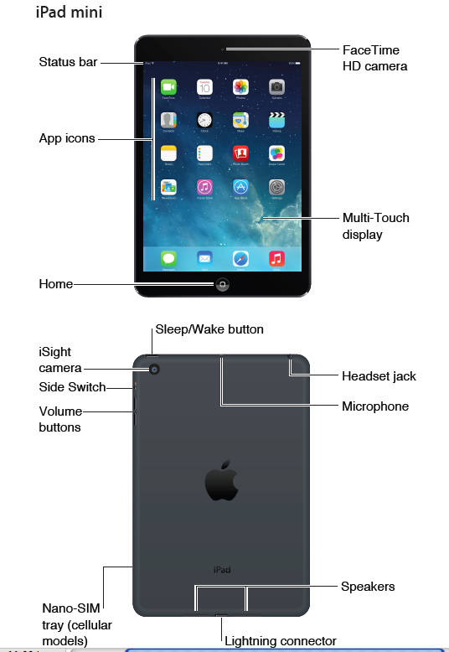
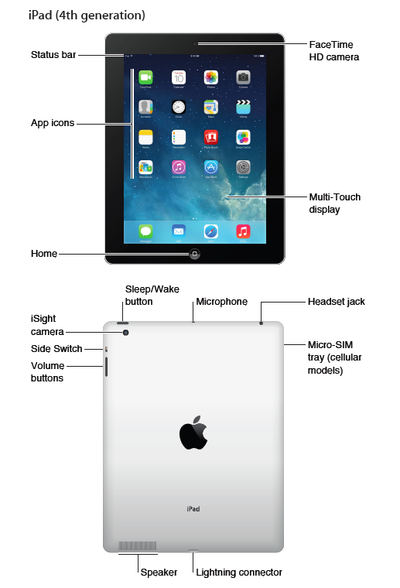

Sleep/Wake button
You can lock iPad and put it to sleep when you’re not using it. When iPad is locked, nothing happens if you touch the screen, but music continues playing and you can use the volume buttons.
- Lock iPad. Press the Sleep/Wake button.
- Unlock iPad. Press the Home button or the Sleep/Wake button, then drag the slider that appears onscreen.
- Turn iPad on. Hold down the Sleep/Wake button until the Apple logo appears.
- Turn iPad off. Hold down the Sleep/Wake button for a few seconds until the red slider appears onscreen, then drag the slider.
- If you don’t touch the screen for two minutes, iPad locks itself. You can change how long iPad waits to lock itself, or set a passcode to unlock iPad.
- Set the auto-lock time. Go to Settings > General > Auto-Lock.
- Set a passcode. Go to Settings > General > Passcode Lock.

Home button
- The Home button takes you back to the Home screen at any time. It also provides other convenient shortcuts.
- Go to the Home screen. Press the Home button.
- On the Home screen, tap an app to open it. More details later
- See apps you’ve opened. Double-click the Home button when iPad is unlocked, then swipe left or right.
- Use Siri (iPad 3rd generation or later). Press and hold the Home button. More info later

Volume buttons and the Side Switch
- Use the Volume buttons to adjust the volume of songs and other media, and of alerts and sound effects. Use the Side Switch to silence audio alerts and notifications. Or, set it to prevent iPad from switching between portrait and landscape orientation.
- Volume buttons Side Switch
Adjust the volume. Press the Volume buttons.
- Mute the sound: Press and hold the Volume Down button.
- Set a volume limit: Go to Settings > Music > Volume Limit.
- Mute notifications, alerts, and sound effects.
- The Side Switch doesn’t mute the audio from music, podcasts, movies, and TV shows.

Status icons
The icons in the status bar at the top of the screen give information about iPad:
Status icon |  | What it means
Wi-Fi | iPad has a Wi-Fi Internet connection. The more bars, the stronger the connection.
Cell signal | iPad (Wi-Fi + Cellular models) is in range of the cellular network. If there’s no signal, “No service” appears.
Airplane Mode | Airplane Mode is on—you can’t access the Internet, or use Bluetooth® devices. Non-wireless features are available
LTE | iPad (Wi-Fi + Cellular models) is connected to the Internet over a 4G LTE network.
4G | iPad (Wi-Fi + Cellular models) is connected to the Internet over a 4G network.
3G | iPad (Wi-Fi + Cellular models) is connected to the Internet over a 3G network.
EDGE | iPad (Wi-Fi + Cellular models) is connected to the Internet over an EDGE network.
GPRS | iPad (Wi-Fi + Cellular models) is connected to the Internet over a GPRS network.
Do Not Disturb | Do Not Disturb is turned on.
Personal Hotspot | iPad is providing a Personal Hotspot for other iOS devices. See Personal
Syncing | iPad is syncing with iTunes.
Activity | There is network or other activity. Some third-party apps use this icon to show app activity.
VPN | iPad is connected to a network using VPN.
Lock | iPad is locked. See Sleep/Wake button
Alarm | An alarm is set.
Screen orientation lock | Screen orientation is locked.
Location Services | An app is using Location Services. See Privacy on page 33.
Bluetooth® | Blue or White icon: Bluetooth is on and paired with a device, such as a headset or keyboard.  Gray icon: Bluetooth is on and paired with a device, but the device is out of range or turned off.  No icon: Bluetooth is not paired with a device.  See Bluetooth devices on page 32.
Bluetooth battery | Shows the battery level of a supported paired Bluetooth device.
Battery | Shows the battery level or charging status. See Charge and monitor the battery

Manage content on your iOS devices
You can transfer information and files between iPad and your other iOS devices and computers, using either iCloud or iTunes.
- iCloud stores content such as music, photos, calendars, contacts, documents, and more, and wirelessly pushes it to your other iOS devices and computers, keeping everything up to date. See iCloud, below.
- iTunes syncs music, video, photos, and more between your computer and iPad. Changes you make on one device are copied to the other when you sync. You can also use iTunes to copy a file to iPad for use with an app, or to copy a document you’ve created on iPad to your computer. See Sync with iTunes below
You can use iCloud or iTunes, or both, depending on your needs. For example, you can use iCloud Photo Stream to automatically push photos you take on iPad to your other devices, and use iTunes to sync photo albums from your computer to iPad.
Note: Don’t sync items in the Info pane of iTunes (such as contacts, calendars, and notes) and also use iCloud to keep that information up to date on your devices. Otherwise, you may see duplicated data on iPad.
iCloud
iCloud stores your content, including music, photos, contacts, calendars, and supported documents. Content stored in iCloud is pushed wirelessly to your other iOS devices and computers set up with the same iCloud account.
Sign in, create an iCloud account, or set iCloud options. Go to Settings > iCloud.
iCloud is available on:
iOS devices with iOS 5 or later
Mac computers with OS X Lion v10.7.2 or later
PCs with the iCloud Control Panel for Windows (Windows 7 or Windows 8 is required)
iCloud features include:
Apps and Books—Download previous App Store and iBookstore purchases for free, anytime.
Mail, Contacts, Calendars—Keep your mail contacts, calendars, notes, and reminders up to date across all your devices.
Documents in the Cloud—For iCloud-enabled apps, keep documents and app data up to date across all your devices.
iTunes in the Cloud—Download previous iTunes music and TV show purchases
Find My iPad—Locate your iPad on a map, display a message, play a sound, lock the screen, or remotely wipe the data. See Find My iPad below
Photos—Use My Photo Stream to send photos you take with your iPad to your other devices, automatically. Use iCloud Photo Sharing to share photos and videos with just the people you choose, and let them add photos, videos, and comments. See iCloud Photo Sharing and My Photo Stream on below
Backup—Back up iPad to iCloud automatically when connected to power and Wi-Fi. See Back up iPad
Find My Friends—Keep track of your family and friends (when connected to a Wi-Fi or cellular network) using the Find My Friends app. Download the free app from the App Store.
iTunes Match—With an iTunes Match subscription, all your music, including music you’ve imported from CDs or purchased somewhere other than iTunes, appears on all your devices and can be downloaded and played on demand. See iTunes Match
iCloud Tabs—See the webpages you have open on your other iOS devices and OS X computers. See Safari section later
With iCloud, you get a free mail account and 5 GB of storage for your mail, documents, and backups. Your purchased music, apps, TV shows, and books, as well as your Photo Stream, don’t count against your free space.

Turn on Automatic Downloads for music, apps, or books. Go to Settings > iTunes & App Store.
View and download previous purchases.
- iTunes Store: You can access your purchased songs and videos in the Music and Videos apps.
- Or, in iTunes Store, tap Purchased .
- App Store: Go to App Store, then tap Purchased .
- iBooks Store: Go to iBooks, tap Store, then tap Purchased .
Find your iPad. Go to www.icloud.com, sign in with your Apple ID, then open Find My iPhone.
Use it to find an iPad or iPod touch, too.
Important: Find My iPad must first be turned on in Settings > iCloud.

Connect iPad to your computer
Use the included USB cable to connect iPad to your computer. Connecting iPad to your
computer lets you sync information, music, and other content with iTunes. You can also sync with
iTunes wirelessly. See Sync with iTunes below.

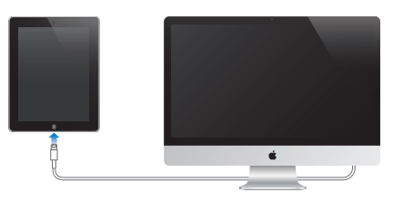
To use iPad with your computer, you need:
- A Mac •• OS X version 10.6.8 or later •• Windows 8, Windows 7, Windows Vista, or Windows XP Home or Professional with Service Pack 3 or later
- iTunes, available at www.itunes.com/download

Sync with iTunes
Syncing with iTunes copies information from your computer to iPad, and vice versa. You can sync by connecting iPad to your computer with the included USB cable, or you can set up iTunes to sync wirelessly using Wi-Fi. You can set iTunes to sync music, photos, videos, podcasts, apps, and more. For information about syncing iPad, open iTunes on your computer, then select iTunes Help from the Help menu.
Sync wirelessly. Connect iPad to your computer using the included USB cable. In iTunes on your computer, select iPad, click Summary, then turn on “Sync with this iPad over Wi-Fi.”
When Wi-Fi syncing is turned on, iPad syncs when it’s connected to a power source, both iPad and your computer are connected to the same wireless network, and iTunes is open on the computer.

Tips for syncing with iTunes on your computer
Connect iPad to your computer, select it in iTunes, and set options in the different panes.
- In the Summary pane, you can set iTunes to sync iPad automatically when it’s attached to your computer. To temporarily override this setting, hold down Command and Option (Mac) or Shift and Control (PC) until you see iPad appear in the iTunes window.
- In the Info pane, click Advanced to select options that let you replace the information on iPad with the information from your computer during the next sync.
- In the Photo pane, you can sync photos and videos from a folder on your computer.

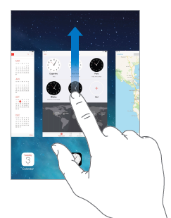
Basics
Use apps
- Tap an app to open it > Press the Home button to return to the Home screen. Swipe left or right to see other screens
- View running apps. Double-click the Home button to reveal the multitasking display. Swipe left or right to see more.
- Quit an app. If an app isn’t working properly, you can force it to quit. Drag the app up from the multitasking display. Then try opening the app again.
If you have lots of apps, you can use Spotlight to find and open them. Pull down the center of the Home screen to get the search field. See Search below

Looking around
- Drag a list up or down to see more. Swipe to scroll quickly; touch the screen to stop it.
- Drag a photo, map, or webpage in any direction to see more.
- To quickly jump to the top of a page, tap the status bar at the top of the screen.

Zoom in or out
Stretch a photo, webpage, or map for a close-up—then pinch to zoom back out. In Photos, keep
pinching to see the collection or album the photo’s in.

Or double-tap a photo or webpage to zoom in, and double-tap again to zoom out. In Maps, double-tap to zoom in and tap once with two fingers to zoom out.

Multitasking gestures
You can use multitasking gestures on iPad to return to the Home screen, reveal the multitasking
display, or switch to another app.
- Return to the Home screen. Pinch four or five fingers together.
- Reveal the multitasking display. Swipe up with four or five fingers.

Change the screen orientation
Many apps give you a different view when you rotate iPad.
- Lock the screen orientation. Swipe up from the bottom edge of the screen to open Control Center, then tap .
- The orientation lock icon appears in the status bar when the screen orientation is locked.
- You can also set the Side Switch to lock the screen orientation instead of silencing sound effects and notifications. Go to Settings > General, and under “Use Side Switch to,” tap Lock Rotation.

Customize iPad

Arrange your apps
- Arrange apps. Touch and hold any app on the Home screen until it jiggles, then drag apps around. Drag an app to the edge of the screen to move it to a different Home screen, or to the Dock at the bottom of the screen. Press the Home button to save your arrangement.
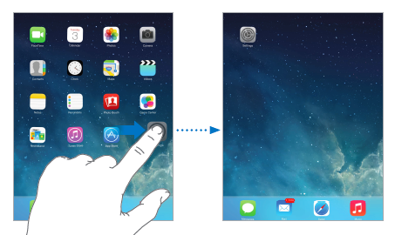
- Create a new Home screen. While arranging apps, drag an app to the right edge of the rightmost Home screen. The dots above the Dock show which of your Home screens you’re viewing.
- Create a folder. While arranging apps, drag one app onto another. Tap the name of the folder to rename it. Drag apps to add or remove them. Press the Home button when you finish.
- Delete a folder. Drag out all the apps—the folder is deleted automatically.

Change the wallpaper
Wallpaper settings let you set an image or photo as wallpaper for the Lock screen or Home screen.
- Change the wallpaper. Go to Settings > Wallpapers & Brightness
Adjust the screen brightness Adjust the screen brightness. Go to Settings > Wallpapers & Brightness and drag the slider. If Auto-Brightness is on, iPad adjusts the screen brightness for current light conditions

Notes
Type notes on iPad, and iCloud makes them available on your other iOS devices and Mac
computers. You can also read and create notes in other accounts, such as Gmail or Yahoo!.
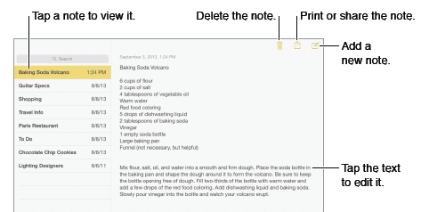
- See your notes on your other devices. If you use icloud.com, me.com, or mac.com for iCloud, go to Settings > iCloud and turn on Notes.
- Search for a note. Tap the Search field at the top of the notes list and type what you’re looking for.
- Share or print a note. Tap at the bottom of the note. You can share via Messages, Mail, or AirDrop.
- Delete a note. Tap , or swipe left over the note in the notes list.

Type text
- Tap Shift to type uppercase. > Double-tap Shift for caps lock. > To enter numbers, punctuation, or symbols, tap the Number key or the Symbol key + * #.
- To quickly end a sentence with a period and a space, just double-tap the space bar.
- Enter accented letters or other alternate characters. Touch and hold a key, then slide to choose one of the options.
- Hide the onscreen keyboard. Tap the Keyboard key .
- Depending on the app and language you’re using, iPad may correct misspellings and anticipate what you’re typing. Accept a suggestion by entering a space or punctuation, or by tapping return. To reject a suggestion, tap the “x.” If you reject the same suggestion a few times, iPad stops suggesting it. If you see a word underlined in red, tap it to see suggested corrections. If the word you want doesn’t appear, type the correction.
- Set options for typing. Go to Settings > General > Keyboard.

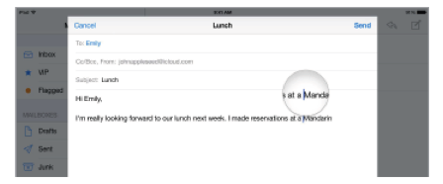
Edit text
- Revise text. Touch and hold the text to show the magnifying glass, then drag to position the insertion point.
- Select text. Tap the insertion point to display the selection options. Or double-tap a word
to select it. Drag the grab points to select more or less text. In read-only documents, such as webpages, touch and hold to select a word.
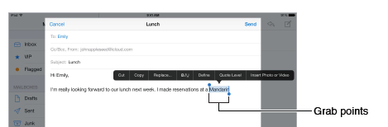
- You can cut, copy, or paste over selected text. With some apps, you can also get bold, italic, or
underlined text (tap B/I/U); get the definition of a word; or have iPad suggest an alternative You may need to tap to see all the options.
- Undo the last edit. Shake iPad, then tap Undo.
- Justify text. Select the text, then tap the left or right arrow (not always available).
- Save keystrokes
- A shortcut lets you enter a word or phrase by typing just a few characters. For example, type
“omw” to enter “On my way!” That one’s already set up for you—to add more, go to Settings >
General > Keyboard. Create a shortcut. Go to Settings > General > Keyboard, then tap Add New Shortcut.

Keyboard layouts
- On iPad, you can type with a split keyboard that’s at the bottom of the screen, or undocked and in the middle of the screen.
- Adjust the keyboard. Touch and hold , then: Use a split keyboard: Slide your finger to Split, then release. Or spread the keyboard apart from the middle.
- Move the keyboard to the middle of the screen: Slide your finger to Undock, then release.
- Return to a full keyboard: Slide your finger to Dock and Merge, then release.
- Return a full keyboard to the bottom of the screen: Slide your finger to Dock, then release.
- Turn Split Keyboard on or off. Go to Settings > General > Keyboard > Split Keyboard.

Dictation
- On an iPad that supports it, you can dictate instead of typing. Make sure Siri is turned on (in Settings > General > Siri) and iPad is connected to the Internet.
Note: Dictation may not be available in all languages or in all areas, and features may vary.
Cellular data charges may apply.
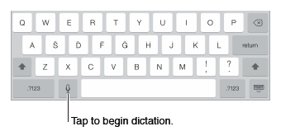
Dictate text. Tap on the iPad keyboard, then speak. When you finish, tap Done.
- Add punctuation or format text. Say the punctuation or format. For example, “Dear Mary comma the check is in the mail exclamation mark” becomes “Dear Mary, the check is in the mail!” Punctuation and formatting commands include:

  - quote … end quote
  - new paragraph
  - new line
  - cap—to capitalize the next word
  - caps on … caps off—to capitalize the first character of each word
  - all caps—to make the next word all uppercase
  - all caps on … all caps off—to make the enclosed words all uppercase
  - no caps on … no caps off—to make the enclosed words all lowercase
  - no space on … no space off—to run a series of words together

Search
Many apps include a search field you can type in to find something that the app knows about. With Spotlight Search, you can search all your apps at once.
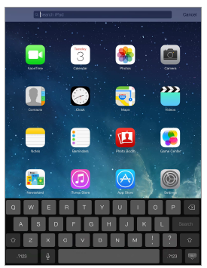
Search iPad Drag down the middle of any Home screen to reveal the search field. Results occur as you type; to hide the keyboard and see more results on the screen, tap Search. Tap an item in the list to open it.
You can use Spotlight Search to find and open apps, too.

Choose which apps and content are searched. Go to Settings > General > Spotlight Search. You can also change the search order.

Control Center
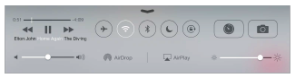
Control Center gives you instant access to the camera, AirDrop, AirPlay, timer, audio playback controls, and other handy features. You can adjust the brightness, lock the screen in portrait orientation, turn wireless services on or off, and turn on AirDrop to exchange photos and other items with nearby iOS 7 devices that support AirPlay. See AirDrop, iCloud, and other ways to share below.

- Open Control Center. Swipe up from the bottom edge of any screen
- Close Control Center. Swipe down, tap the top of the screen, or press the Home button.

Alerts and Notification Center
Alerts let you know about important events. They can appear briefly at the top of the screen, or remain in the center of the screen until you acknowledge them.
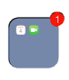
Some apps may include a badge on their Home screen icon, to let you know how many new items await—for example, the number of new email messages. If there’s a problem—such as a message that couldn’t be sent—an exclamation mark appears on the badge. On a folder, a numbered badge indicates the total number of notifications for all the apps inside.
- Silence your alerts. Go to Settings > Do Not Disturb.
- Set sounds. Go to Settings > Sounds

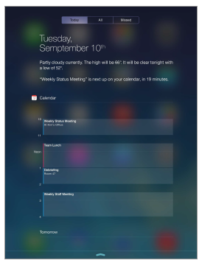
Notification Center

Notification Center collects your notifications in one place, so you can review them whenever you’re ready. Review all your alerts, or just the ones you missed. Or tap the Today tab for a summary of the day’s events—such as the weather forecast, appointments, birthdays, stock quotes, and even a quick summary of what’s coming up tomorrow.

Open Notification Center. Swipe down from the top edge of the screen.
Set notification options. Go to Settings > Notification Center. Tap an app to set its notification options. You can also tap Edit to arrange the order of app notifications. Touch and drag it to a new position.

Close Notification Center. Swipe up.

Sounds and silence
You can change or turn off the sounds iPad plays when you get a FaceTime call, text message, email, tweet, Facebook post, reminder, or other event.
- Set sound options. Go to Settings > Sounds for options such as alert tones and ringtones, and ringer and alert volumes.
- If you want to temporarily silence incoming FaceTime calls, alerts, and sound effects, see the following section.

Do Not Disturb

Do Not Disturb is an easy way to silence iPad, whether you’re going to dinner or to sleep. It keeps FaceTime calls and alerts from making any sounds or lighting up the screen.
- Turn on Do Not Disturb. Swipe up from the bottom edge of the screen to open Control Center, then tap . When Do Not Disturb is on, appears in the status bar.
Note: Alarms still sound, even when Do Not Disturb is on. To make sure iPad stays silent, turn it off.
- Configure Do Not Disturb. Go to Settings > Do Not Disturb.
- You can schedule quiet hours, allow FaceTime calls from your Favorites or groups of contacts, and allow repeated FaceTime calls to ring through for those emergency situations. You can also

AirDrop, iCloud, and other ways to share
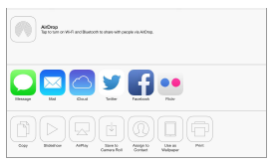
In many apps, you can tap Share or to see sharing and other options. The options vary depending on the app you’re using.

AirDrop lets you share your photos, videos, websites, locations, and other items wirelessly with other nearby iOS 7 devices that support AirDrop. AirDrop requires an iCloud account, and transfers info using Wi-Fi and Bluetooth. You must be on the same Wi-Fi network, or within approximately 30 feet (10 meters) of the other device. Transfers are encrypted for security. Video tutorial: http://vimeo.com/76392076

- Share an item using AirDrop. Tap Share or , then tap AirDrop and tap the name of a nearby AirDrop user. AirDrop is also available in Control Center—just swipe up from the bottom edge of the screen.
- Receive AirDrop items from others. Swipe up from the bottom edge of the screen to open Control Center. Tap AirDrop, then choose to receive items from Contacts only or from Everyone. You can accept or decline each request as it arrives.
- Add photo or video to a shared stream. Tap iCloud (a sharing option in the Photos app), choose a stream (or create a new one), then tap Post.
- Use Twitter, Facebook, Flickr, or Vimeo. Sign in to your account in Settings. The Twitter, Facebook, Flickr, and Vimeo sharing buttons take you to the appropriate setting if you’re not yet signed in.
Note: While you’re composing a tweet, the number in the lower-right corner shows the number of characters remaining. Attachments use some of a tweet’s 140 characters.

Transfer files
- There are several ways to transfer files between iPad and your computer or other iOS device. If you have an app that works with iCloud on multiple devices, you can use iCloud to automatically keep the app’s documents up to date across your devices.

- You can transfer files using iTunes. Connect iPad to your computer using the included cable. In iTunes on your computer, select iPad, then click the Apps button. Use the File Sharing section to transfer documents between iPad and your computer. Apps that support file sharing appear in the Apps list. To delete a file, select it in the Documents list, then press the Delete key.

- You can also view files received as email attachments on iPad.

Personal Hotspot
Use Personal Hotspot to share your iPad (Wi-Fi + Cellular models) Internet connection. Computers can share your Internet connection using Wi-Fi, Bluetooth, or a USB cable. Other iOS devices can share the connection using Wi-Fi. Personal Hotspot works only if iPad is connected to the Internet over the cellular data network.

Note: This feature may not be available with all carriers. Additional fees may apply. Contact your carrier for more information.

Share an Internet connection. Go to Settings > Cellular and tap Set Up Personal Hotspot—if it appears—to set up the service with your carrier.

After you turn on Personal Hotspot, other devices can connect in the following ways:
- Wi-Fi: On the device, choose your iPad in the list of available Wi-Fi networks.
- USB: Connect your iPad to your computer using the cable that came with it. In your computer’s Network preferences, choose iPad and configure the network settings.
- Bluetooth: On iPad, go to Settings > Bluetooth and turn on Bluetooth. To pair and connect iPad with your device, refer to the documentation that came with your computer.
Note: When a device is connected, a blue band appears at the top of the iPad screen. The Personal Hotspot icon appears in the status bar of iOS devices using Personal Hotspot.

- Change the Wi-Fi password for iPad. Go to Settings > Personal Hotspot > Wi-Fi Password, then enter a password of at least eight characters.
- Monitor your cellular data network usage. Go to Settings > Cellular. See Cellular settings on below

AirPlay
Use AirPlay to stream music, photos, and video wirelessly to Apple TV and other AirPlay-enabled devices on the same Wi-Fi network as iPad.
- Display the AirPlay controls. Swipe up from the bottom edge of the screen to open Control Center, then tap .
- Stream content. Tap , then choose the device you want to stream to.
- Switch back to iPad. Tap , then choose iPad.
- Mirror the iPad screen on a TV. Tap , choose an Apple TV, then tap Mirroring. A blue bar appears at the top of the iPad screen when AirPlay mirroring is turned on.
- You can also connect iPad to a TV, projector, or other external display using the appropriate Apple cable or adapter. See support. http://apple.com/kb/HT4108.

AirPrint
Use AirPrint to print wirelessly to an AirPrint-enabled printer, from apps such as Mail, Photos, and Safari. Many apps available on the App Store also support AirPrint.
- iPad and the printer must be on the same Wi-Fi network. For more information about AirPrint, see support. http://apple.com/kb/HT4356.
- Print a document. Tap (depending on the app you’re using).
- See the status of a print job. Double-click the Home button, then tap Print Center. The badge on the icon shows how many documents are in the queue.
- Cancel a job. Select it in the Print Center, then tap Cancel Printing.

Restrictions
You can set restrictions for some apps, and for purchased content. For example, you can restrict explicit music from appearing in playlists, or disallow changes to certain settings. Use restrictions to prevent the use of certain apps, the installation of new apps, or changes to accounts or the volume limit.
- Turn on restrictions. Go to Settings > General > Restrictions, then tap Enable Restrictions. You’ll be asked to define a restrictions passcode that’s necessary in order to change the settings you make. This can be different than the passcode for unlocking iPad.
Important: If you forget your restrictions passcode, you must restore the iPad software. See Restore iPad below

Privacy
Privacy settings let you see and control which apps and system services have access to Location Services, and to contacts, calendars, reminders, and photos.
- Location Services lets location-based apps such as Maps, Camera, and Passbook gather and use data indicating your location. Your approximate location is determined using available information from local Wi-Fi networks (if you have Wi-Fi turned on). The location data collected by Apple isn’t collected in a form that personally identifies you. When an app is using Location Services, appears in the menu bar.
- Turn Location Services on or off. Go to Settings > Privacy > Location Services. You can turn it off for some or for all apps and services. If you turn off Location Services, you’re prompted to turn it on again the next time an app or service tries to use it.
- Turn Location Services off for system services. Several system services, such as location-based iAds, use Location Services. To see their status, turn them on or off, or show in the menu bar when these services use your location, go to Settings > Privacy > Location Services > System Services.
- Turn off access to private information. Go to Settings > Privacy. You can see which apps and features have requested and been granted access to the following information:

Security
Security features help protect the information on your iPad from being accessed by others.

Use a passcode with data protection
Initially, iPad doesn’t require you to enter a passcode to unlock it. You can set a passcode that must be entered each time you turn on or wake up iPad.
- Set a passcode. Go to Settings > General > Passcode Lock and set a 4-digit passcode.
- Turn off Simple Passcode and use a longer passcode. To enter a passcode that’s a combination of numbers and letters, you use the keyboard. If you prefer to unlock iPad using the numeric keypad, set up a longer passcode using numbers only.
- Allow access to features when iPad is locked. Go to Settings > General > Passcode Lock. Optional features include:

Allow access to features when iPad is locked. Go to Settings > General > Passcode Lock. Optional features include:
- Siri (if enabled; see Siri settings below
- Allow access to Control Center when iPad is locked. Go to Settings > Control Center. See Control Center info above

Limit Ad Tracking
Restrict or reset Ad Tracking. Go to Settings > General > Privacy > Advertising. Turn on Limit Ad Tracking to prevent apps from accessing your iPad advertising identifier. For more information, tap Learn More.

Find My iPad can help you locate and secure your iPad using the free Find My iPhone app (available in the App Store) on another iPad, iPhone, or iPad, or using a Mac or PC web browser signed in to www.icloud.com. Activation Lock is enabled automatically when you turn on Find My iPad. It can help deter theft by requiring your Apple ID and password before anyone can erase or reactivate your iPad.
- Turn on Find My iPad. Go to Settings > iCloud.
Important: To use these features, Find My iPad must be turned on before your iPad is lost. iPad must be able to connect to the Internet for you to locate and secure the device.
- Use Find My iPhone. Open the Find My iPhone app on an iOS device, or go to www.icloud.com on your computer. Sign in and select your device.

Airplane Mode Travel with iPad
Your airline carrier may let you keep your iPad turned on if you switch to Airplane Mode
Wi-Fi and Bluetooth are turned off in Airplane Mode, so you can’t make or receive FaceTime calls or use features that require wireless communication. You can listen to music, play games, watch videos, or use other apps that don’t require Internet access.

Turn on Airplane Mode. Swipe up from the bottom edge of the screen to open Control Center,
then tap . You can also turn Airplane Mode on or off in Settings. When airplane mode is on,
appears in the status bar at the top of the screen.
- You can also turn Wi-Fi and Bluetooth on or off in Control Center.

Siri
Summon Siri > Press and hold the Home button, until Siri beeps.

Note: To use Siri, iPad must be connected to the Internet
- Ask Siri anything, from “set the timer for 3 minutes” to “what movies are showing tonight?”
Open apps, and turn features on or off, like Bluetooth, Do Not Disturb, and Accessibility. Siri
understands natural speech, so you don’t have to learn special commands or keywords.
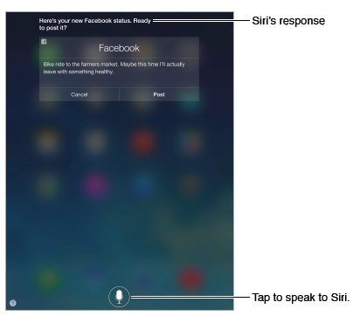
- For hints, ask Siri “what can you do,” or tap .
or visit SIRI diction guide (http://tinyurl.com/siriDiction) and SIRI assistant guide (http://tinyurl.com/SiriGuide1
- Siri often displays helpful info on your screen. Tap the info to open a related app or get more details.
- Change Siri’s voice gender. Go to Settings > General > Siri (may not be available in all areas).
- Talk to Siri using a headset. Connect the headset, then press and hold the center or call button.
- Make corrections
- Want to cancel that last command? Say “cancel,” tap the Siri icon, or press the Home button.
- If Siri doesn’t work set options for Siri, go to Settings > General > Siri. Options include:
Turning Siri on or off, Language, Voice gender (may not be available in all areas), Voice feedback, My Info card
Safari
Use Safari on iPad to browse the web. Add web clips to the Home screen for quick access. Use Reading List to collect sites to read later.
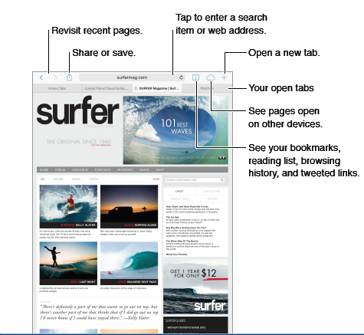
Browse the web
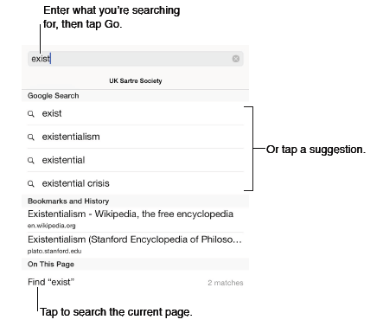
- Have your favorites top the list. Select them at Settings > Safari > Favorites.
- Search the page. Scroll to the bottom of the suggested results list and tap the entry under On This Page. Tap > in the bottom left to see the next occurrence on the page. To search the page for a different term, enter it in the field at the bottom of the page. To continue browsing, tap Done.
- Choose your search tool. Go to Settings > Safari > Search Engine.
- Open a link in a new tab. Touch and hold the link, then tap Open in New Tab. If you’d like to switch to a new tab when you open it, go to Settings > Safari and turn off Open New Tabs in Background.
- Switch tabs Tap a tab at the top of the page.
- Get back to the top Tap the top edge of the screen to quickly return to the top of a long page

Keep bookmarks

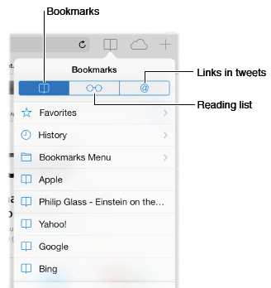

- Bookmark the current page. Tap , then tap Bookmark. To revisit the page, tap , then tap the bookmark.
- Get organized. To create a folder for bookmarks, tap , then tap Edit.
- Choose which favorites appear when you tap the search field. Go to Settings > Safari > Favorites.
- Save a webclip shortcut on your Home screen. Tap , then tap Add to Home Screen.
Safari settings
- Go to Settings > Safari, where you can:
- Choose your search engine
- Provide AutoFill information
- Choose which favorites are displayed when you search
- Have new tabs open in the background
- Display your Favorites at the top of the page
- Block pop-ups
- Tighten privacy and security
- Clear your history, cookies, and data

Fill in forms
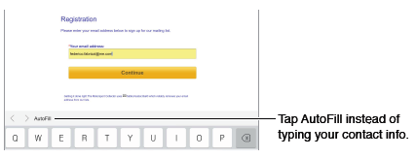
You can fill in a web form using the onscreen keyboard or have Safari fill it in for you using AutoFill.

- When you’re asked if you want to save the password for the site, tap Yes.
- Fill in a form. Tap any field to bring up the onscreen keyboard. Tap or above the keyboard to
move from field to field.
- Fill it in automatically. Go to Settings > Safari > Passwords & Autofill and turn on Use Contact Info. Then, tap AutoFill above the onscreen keyboard when you’re filling in the form. Not all websites support AutoFill.
- Enter your credit card information. Go to Settings > Safari > Autofill and save your credit
card information, then look for the AutoFill Credit Card button above the onscreen keyboard whenever you’re in a credit card field. Your card’s security code is not stored, so you still enter that yourself.
- Submit the form. Tap Go, Search, or the link on the webpage.
Reader Use Safari Reader to focus on a page’s primary content 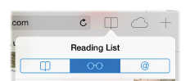
- Add the current page to your reading list. Tap , then tap Add to Reading List.
- Add a linked page without opening it. Touch and hold the link, then tap Add to Reading List.
- View your reading list. Tap , then tap .
- Delete something from your reading list. Swipe left on the item in your reading list.

Privacy and security
You can adjust Safari settings to keep your browsing activities to yourself and protect yourself
from malicious websites.
- Keep a low profile? Turn on Settings > Safari > Do Not Track. Safari will ask websites you visit to not track your browsing, but beware—a website can choose not to honor the request.
- Control cookies. Go to Settings > Safari > Block Cookies. To remove cookies already on iPad, go to Settings > Safari > Clear Cookies and Data.
- Erase your browsing history and data from iPad. Go to Settings > Safari > Clear History, and Settings > Safari > Clear Cookies and Data.

