Getting Started
Step 1. Launch iMovie and tap the + button to create a new project. You can choose between a Movie and a Trailer. Trailers are fun, but we’ll focus on Movie mode here. Tap Movie and then choose a theme. You can tap the play button to watch a preview of each style.

Step 2. You can change the theme later, so don’t worry too much. Choose one and tap Create Movie in the top-right corner. You’ll see the editing screen, with your videos to the right, a preview monitor on the left and, running across the bottom, the timeline, which is currently blank.

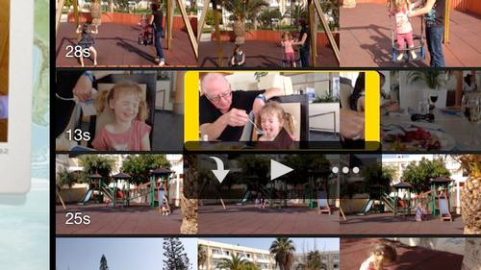
Step 3. Tap on a video and it will be highlighted in yellow. You can drag the left- and right-hand edges to trim the clip before you add it to the timeline, or you can add the whole clip (by tapping the downward arrow) and trim it later.

Step 4. You can zoom in and out on the timeline by dragging two fingers apart along the timeline, very helpful when making precise edits. For now, tap on the video clip to select it, and you’ll see some options appear at the bottom.
- Move a clip by holding a finger down on it and drag to new location.
- Split Clip by tapping a clip > move edit line to where you want to split > tap split at the bottom right
- Freeze Frame by tapping a clip > move edit line to where you want to capture a freeze frame and tap Freeze at the bottom (good for titles)
- Ken Burns Effect > Add photo > a start and end option will appear bottom right of play monitor > pinch and set zoom

Step 6. Tap audio (lower Left) and you can adjust the clip’s volume. It’s useful to see the audio track, so make sure this is visible by tapping the squiggly line next to the undo arrow at the top-right of the timeline. Importantly, there’s also a Detach option, (bottom right ) which we’ll use later.

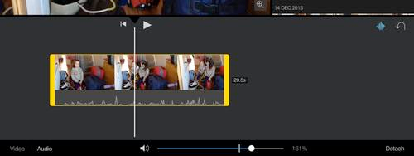
Step 7. Tap the play button at the top of the timeline to play your movie. You can scrub through the clip by swiping left or right on the timeline. The white vertical line is the edit line, Make sure the line is in the right-hand half of the clip before adding another video to the timeline.

Step 7. Add another video to the timeline by repeating step 4 and you’ll see the transition icon between the clips. Tap it and the options appear at the bottom. The default is dissolve, but the others, left to right, are straight cut, theme special, slide, wipe and dip-to-black (or white). The latter three have additional options when you select them.

Step 8. You can change a transition’s duration by tapping the ‘1.0s’ option at the bottom right, and then choosing either 0.5s, 1.5s or 2.0s. (not available for all transitions ). Some transitions have a sound effect, which is muted by default. Tap the speaker icon to toggle sound on and off.

Step 9. Tap the first video on the timeline and then tap the Title option at the bottom right. Now tap Opening on the left and the theme’s title will be added to the clip. Simply tap on the text in the preview window to edit it. With this Travel theme, a marker points to a destination.
  - You can alter this by tapping the pin icon ( bottom right) and then typing in a place name.
  - To change the pin location > tap the pin icon > tap magnifying glass > type new location and select closest option.
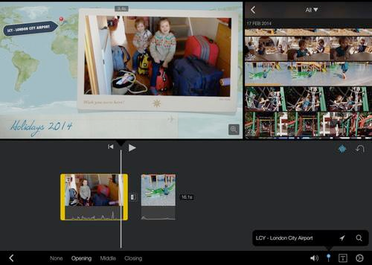
  - Change Font by tapping the text icon at the bottom right.

Step 11. In the example below I added an establishing shot of the hotel, followed by a clip showing inside the room. To give your video a pro feel, you can make the audio from the second clip play over the establishing shot. ( L cut) Tap on the shot inside the room, then on Audio, then Detach. The clip’s audio is shown in blue beneath it.

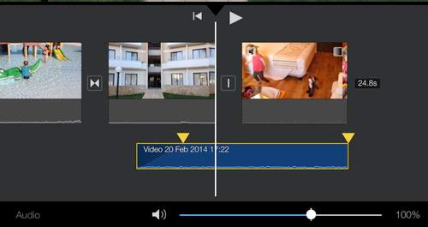
Step 12. As with video clips, you can tap and hold on an audio clip to move it on the timeline. For added narration this world best. However, to keep it in synch with your video, don’t do this. Instead, select the video to which it belongs and trim it by dragging the left-hand yellow bar to the right. The audio won’t be trimmed, and will extend beneath the previous clip – the establishing shot. (This takes practice to grab the end)

Step 13. To complete the edit, tap on the transition between the two clips and change it from dissolve to a straight cut. Play the two clips and you’ll see a seamless transition between them, with the continuous audio making it a lot less jarring. It’s a technique used in almost every TV show, and is very effective.

Step 14. You’ll want some background music, so tap the Audio button at the top-right corner of the screen. You can choose iMovie’s own music, or any other music on your iPad. Select a song and tap the downward arrow to add it to the timeline.

Step 15. iMovie doesn’t allow gaps, so it will insert the song at the start of your movie. If you don’t want that, or want to have a gap between songs, just trim the clip to the point where you want music to start, and use the Fade option at the bottom right

Step 16. Now you can repeat step 15, adding the song again (or a different song). Note that iMovie will automatically reduce the song’s volume during a video clip that has audio, but will otherwise play at the volume you set.

Step 17. Continue to add clips, and perhaps adding other titles. Tap on a grey area of the timeline to deselect any clips, then tap the cog icon at the bottom right. This offers options to fade your movie in from black and out to black, as well as letting you change the theme. Changing theme will change all titles, special transitions and even transition sound effects.

Step 18. When you’re finished editing, tap the back-pointing arrow in the top-left corner and you can tap on the title to edit it. The play button lets you watch the movie full-screen, and tapping the clapper board takes you back into editing mode. Tap the upward-pointing arrow to share your creation. If you want to have the movie in your Camera Roll, tap Save video and then choose the quality

