iPad Trailer Tutorial

- Three tabs run along the top of iMovie’s interface: Video, Projects and Theatre. We’ve already dealt with Video (see here), so tap on Projects. Any project you’ve previously created on your iPad or iPhone will be listed here.
- Tap the + button at the bottom of the interface to access options to create a movie or a trailer. Choose Trailer, then select one of the 14 templates provided. You can press the play button to preview a selected template. When you’ve found one you like, tap Create Trailer.
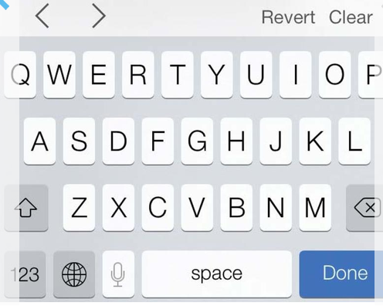
- The project is divided into two sections: Outline and Storyboard. Use Outline to enter a title, names of the main characters, details of the production crew and other information. You can choose one of five animations for your logo, and enter your studio’s name. Fill in all the details requested, then move on to Storyboard.
- Storyboard is your project broken down into clips. A generic thumbnail shows you at a glance whether the trailer requires a medium-, group,- close-up- or an action shot. You can replace the caption placeholder text for each clip, but remember to keep it short – the text won’t be onscreen for long.
- To move between text fields either tap on the next field onscreen or use the arrow icons above the keyboard. Also here is a Clear button, which will remove the placeholder text. Revert reinstates the original text. Having filled in all the blanks, now it’s time to add some clips.
- Scroll up to the beginning of the Storyboard and tap on the first placeholder clip. You can either take a shot using your camera or choose a video clip or still image stored on your device.
- With your finger Drag the selection to choose a particular portion of a clip or pinch in or out to zoom. Although you can’t alter its length (only move the start- and end points), you can swap in action shots where iMovie requests close-ups and the like. Press the Play button to preview the clip, then tap the curved arrow button to add it to the project.
- Having inserted your first clip, iMovie will prompt you for the next; simply repeat the process in Step 7. It is possible to skip placeholder clips and build your project out of sequence. To return to a previously inserted clip and either make adjustments or delete it just tap on its thumbnail.
- Photos - iMovie automatically adds a Ken Burns effect to your photo; if you wish to edit this and pan and zoom as you want, tap on your clip once more.
- At the bottom of the interface are Start and End buttons. You can pinch to zoom in on a photo, then select a specific place to start the effect. Tap the End button, then repeat the process. When you’re done press Play to preview the effect, and Done to return to your trailer. Tap Play to view your trailer.

