Send video from one ipad to another.

- Download Wireless Transfer App and install it on iPad
- 2. Make sure both iPads are connected to the same Wi-Fi network.
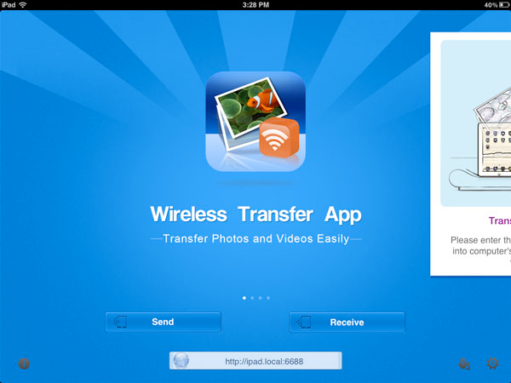
- 3. Make sure both iPads have Wireless Transfer App running.

4. Tap the "Receive" button on your iPad. Then you will find the device name of the other iPad.

5. Tap the name of the other iPad. All photos and videos in this iPad's photo library will be listed.

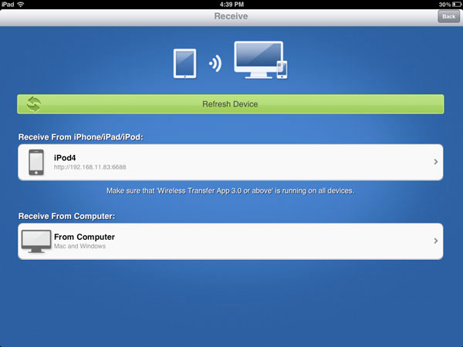
6. Select the photos and videos that your want to transfer. Tap the "Download" button to start the transfer. The selected photos and videos will be downloaded to the photo library in your iPad.

7. Launch the "Photos" app in your iPad and you will find all the photos and videos downloaded from the other iPad.

